**How to use the Data logger Air Core v2.0**

************ AIR core hardware ************

1. Place the air core on a table and open it.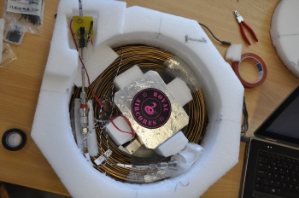
2. Remove the small foam and open the Royal Air cores Box. Remove the data logger out of the box; please, grab it by the battery or the metal plate. Be careful. 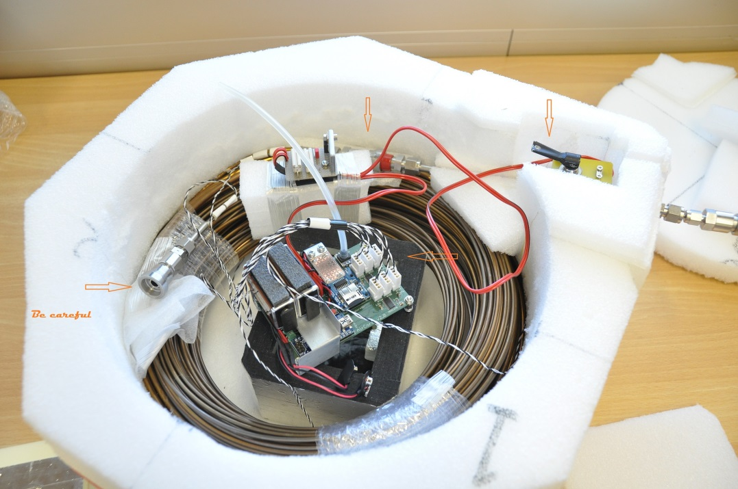
3. Replace the two 9 Volt (*pre.* Lithium) batteries and check the micro-SD card is present. 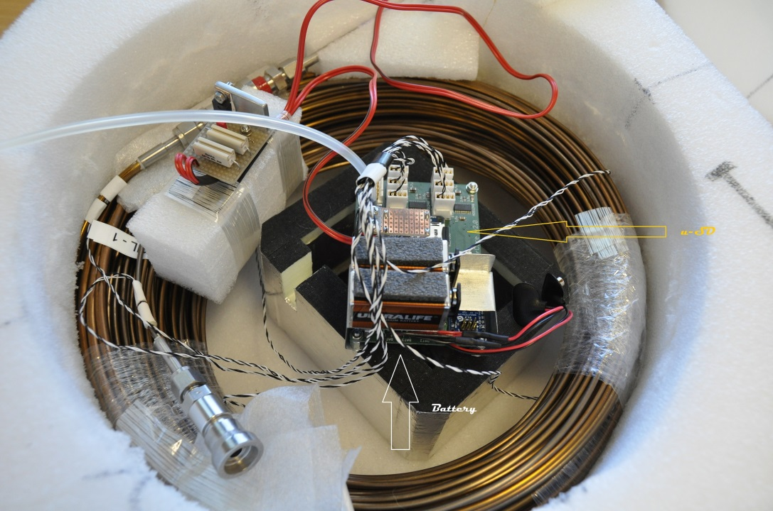
4. Take the computer with the **Adruino** software and start it. The computer will be connected with the data logger, by a mini usb cable. 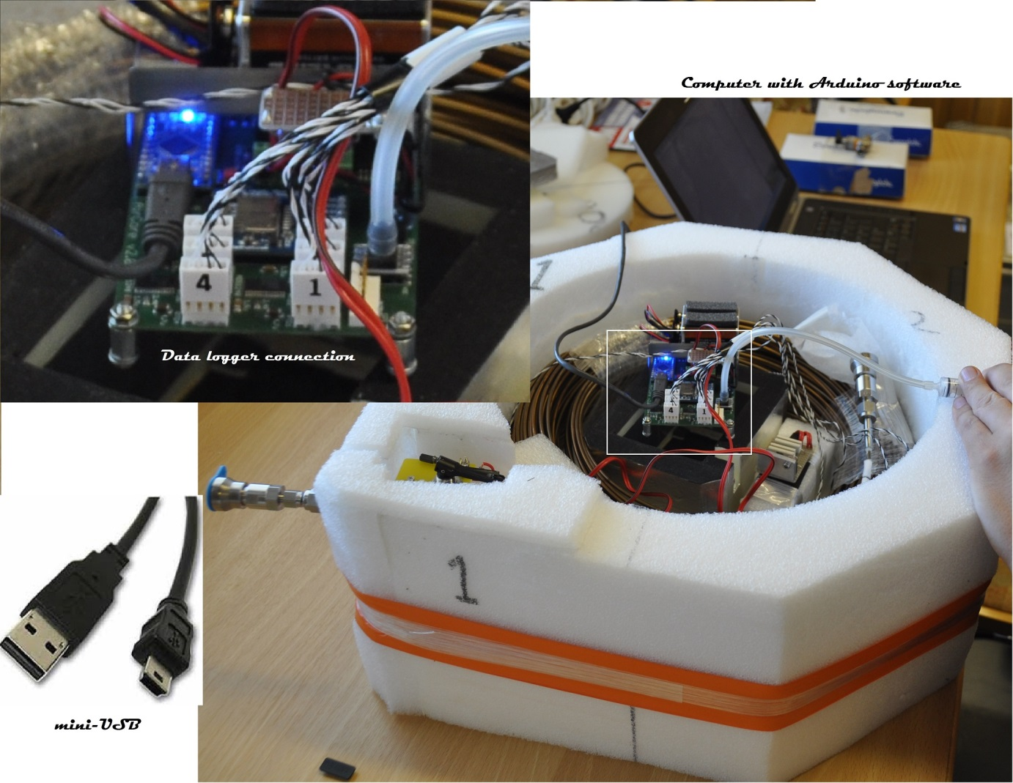

************ AIR core software ************

1. Open the Arduino software. 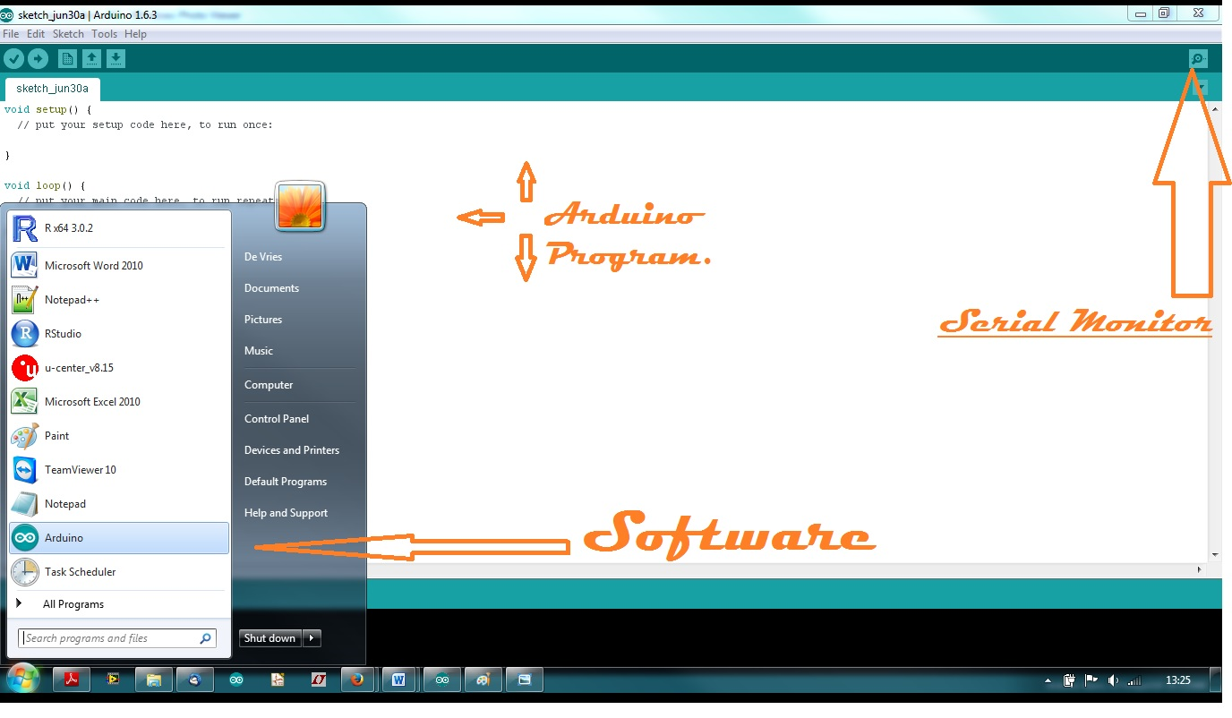
2. Open the “SERIAL MONITOR”, on the top left.
3. When it is right, the next text will be showed. “…working is loadmode. Give a command: “ 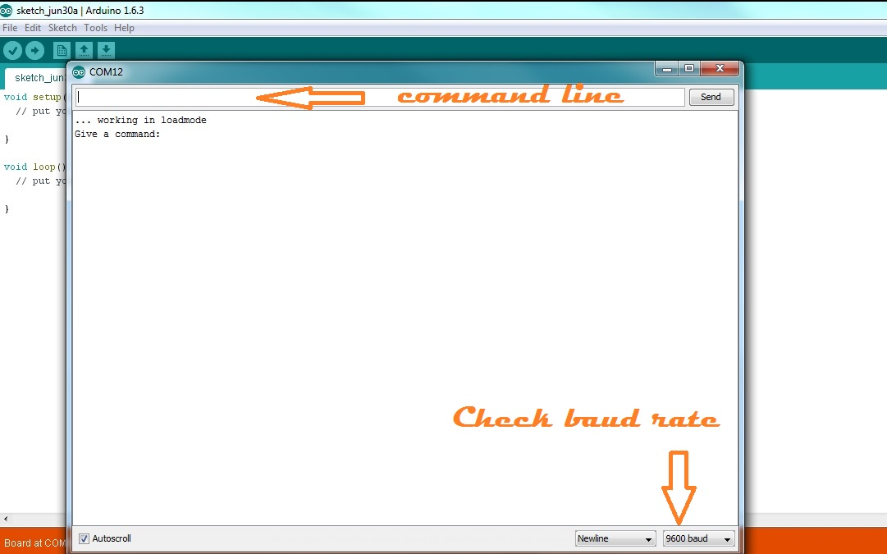
4. Give command, to set the time: “!TIME” 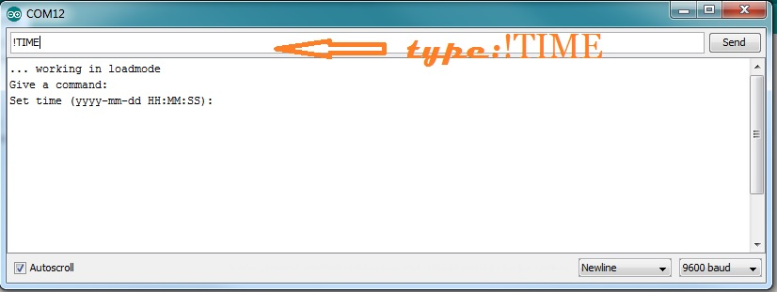
5. Give command, give the time: ”2015-06-30 16:00:00”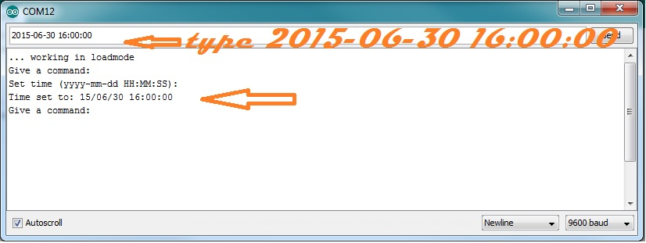
6. Give command, get the time: “?TIME” . It will replay the time, 15 times.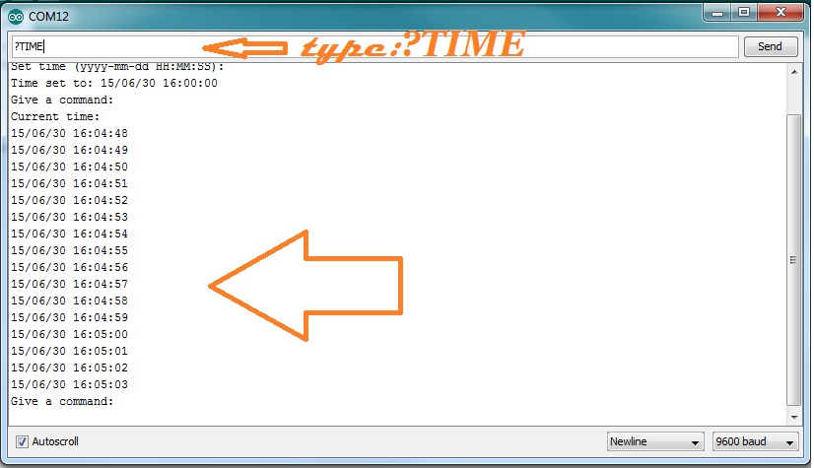

Give command, “QUIT”. This will stop initialization and start program. 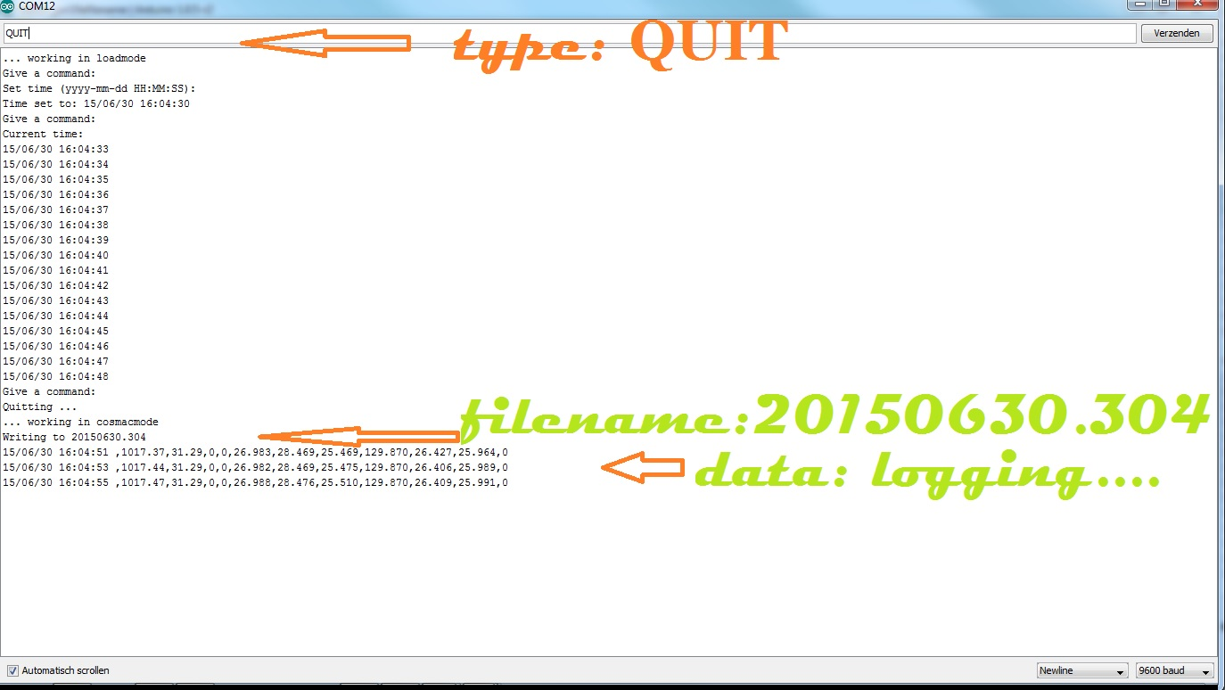

************ AIR core automatic valve ************

1. Place all back, data logger is ready. 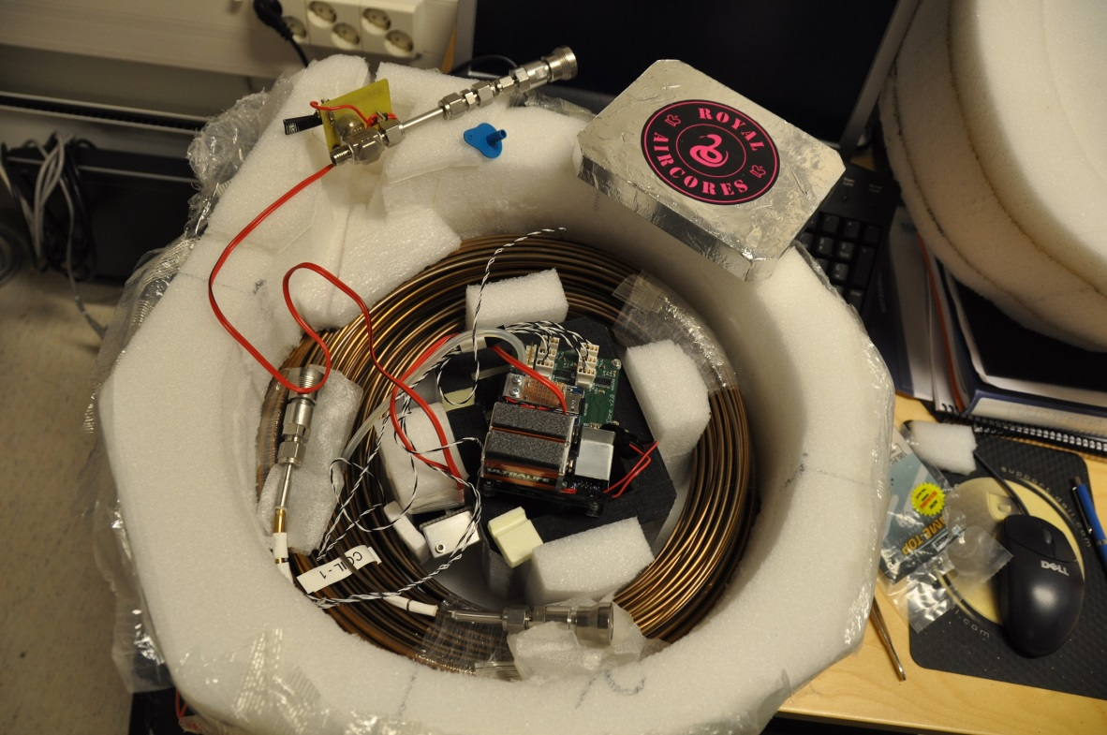
2. Only the automatic valve has to be set. 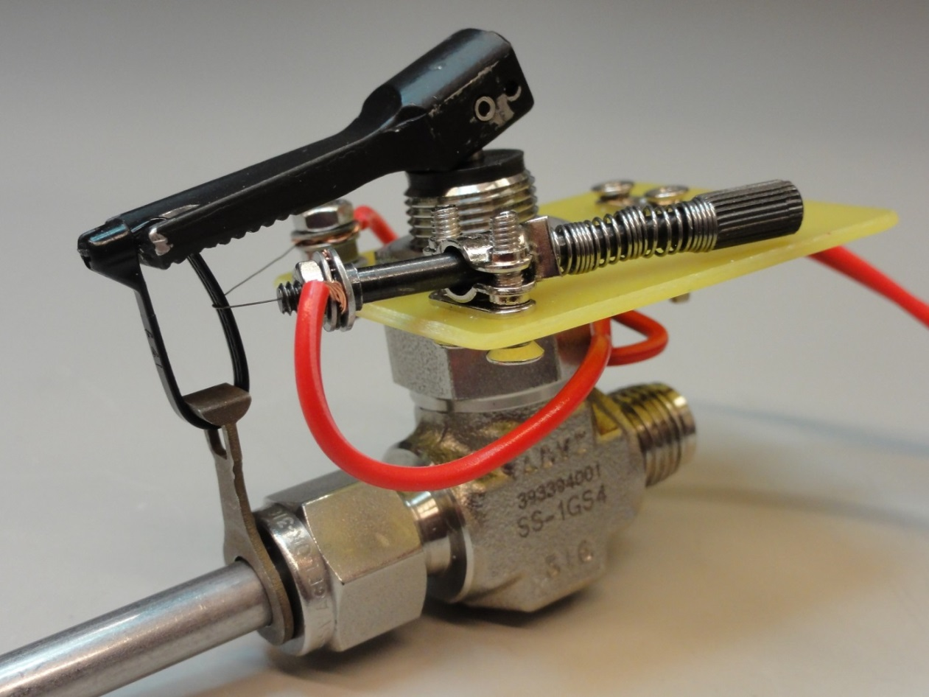
3. Or like this.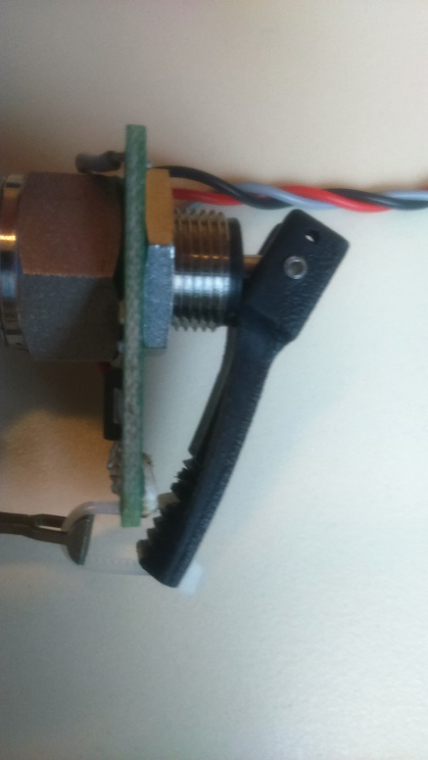
4. Finished. Put the blue seal on the inlet, till lanch. Don´t forget it. 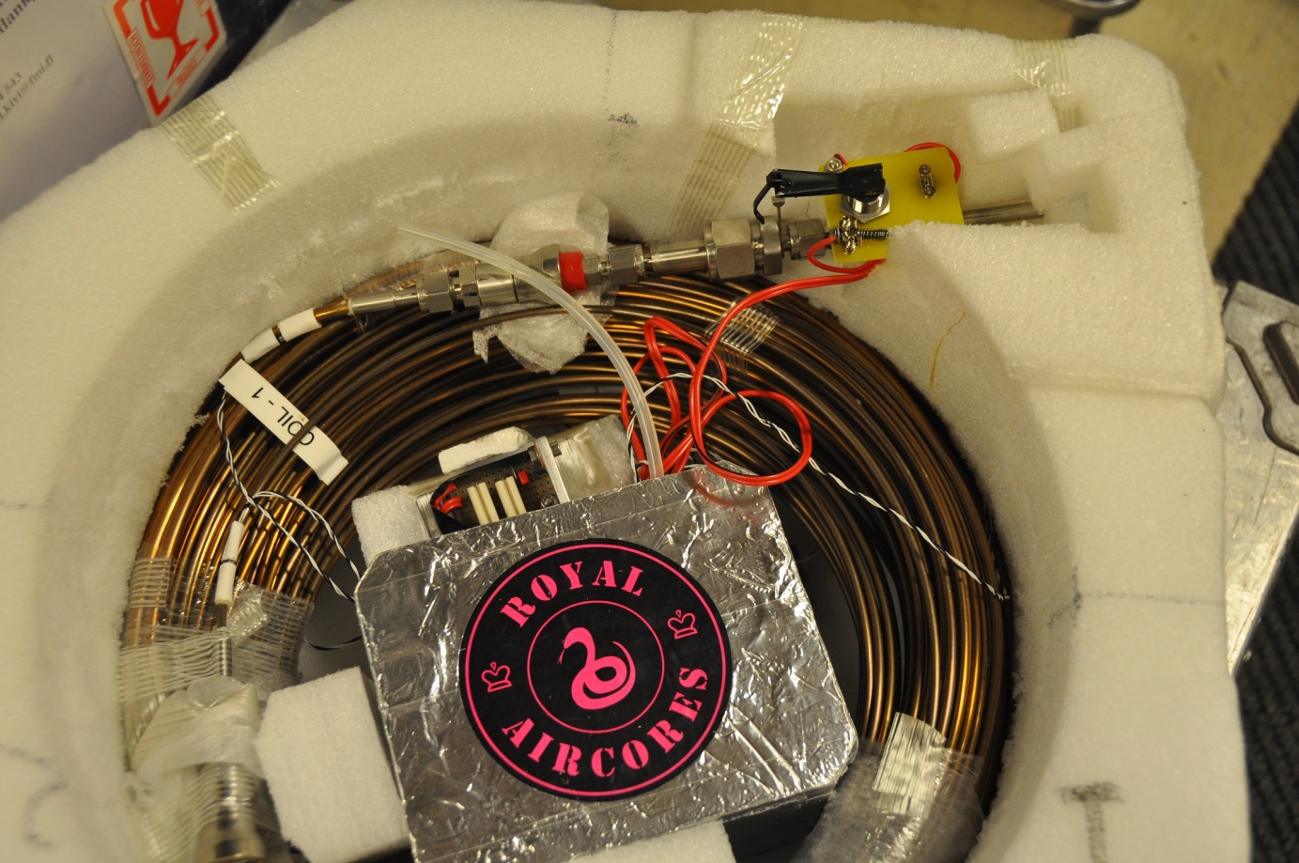

************ AIR core software problems ************

1. Check BOARD : ->Tools->Board->Arduino Nano

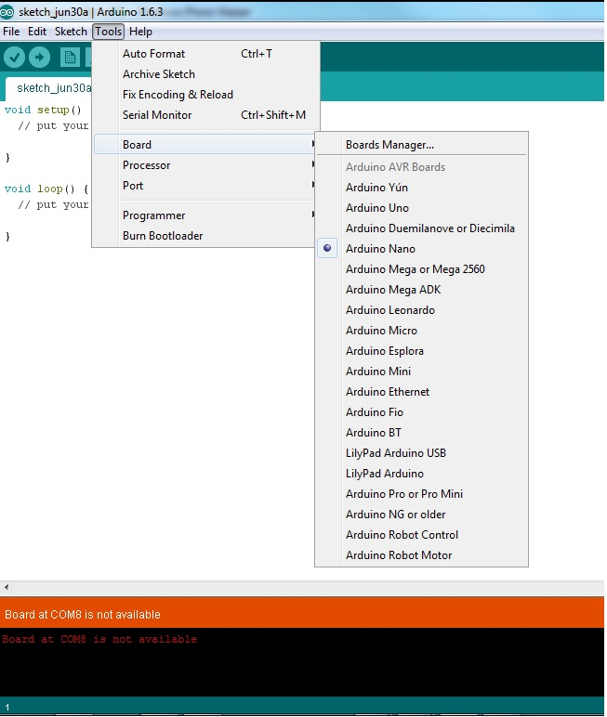

1. Check Processor: -> Tools->Processor->ATMega328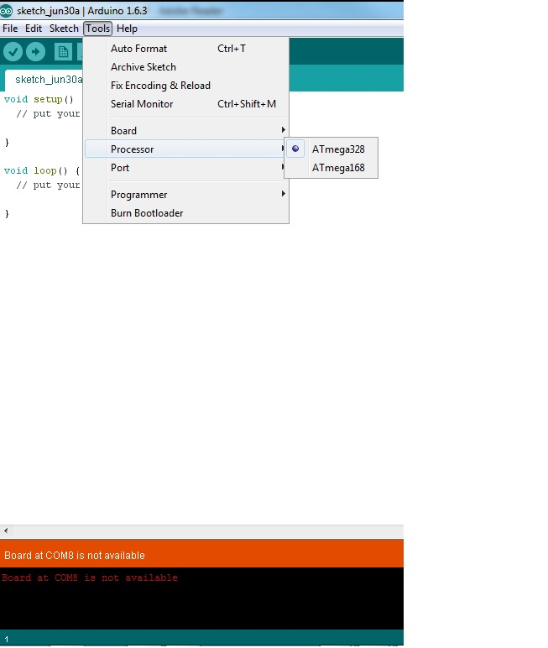
2. Check Port: ->Tools->Port

